AI ASSISTED CODING
ASSIGNMENT - 14.3
NAME: P.SAI SHANKAR
HL-NO: 2303A52500 BATCH: 50
Lab 14.3
Task-1:
HTML:
<!DOCTYPE html>
<html lang="en">
<head>
<meta charset="UTF-8">
<meta name="viewport" content="width=device-width, initial-scale=1.0">
<title>Personal Portfolio Website</title>
<style>
/* CSS for layout and design */
:root {
--primary-color: #333;
--accent-color: #007bff;
--light-bg: #f4f4f4;
--text-color: #333;
--white: #fff;
}

/* Smooth scrolling */
html {
scroll-behavior: smooth;
}
body {
font-family: Arial, sans-serif;
margin: 0;
padding: 0;
line-height: 1.6;
color: var(--text-color);
}
header {
background: var(--primary-color);
color: var(--white);
padding: 1rem 0;
position: sticky;
top: 0;
z-index: 1000;
}
nav {
display: flex;
justify-content: space-between;
align-items: center;
max-width: 1200px;
margin: 0 auto;
padding: 0 2rem;
}
.logo {
font-size: 1.5rem;
font-weight: bold;
}
.nav-links {
display: flex;
list-style: none;
}
.nav-links li {
margin-left: 2rem;
}
.nav-links a {
color: var(--white);
text-decoration: none;
transition: color 0.3s;
}
.nav-links a:hover {
color: var(--accent-color);
}
section {
padding: 4rem 2rem;
max-width: 1200px;
margin: 0 auto;
}
#home {
height: 80vh;
display: flex;
flex-direction: column;
justify-content: center;
align-items: center;
text-align: center;
background: var(--light-bg);
}
.projects-grid {
display: grid;
grid-template-columns: repeat(auto-fit, minmax(300px, 1fr));
gap: 2rem;
margin-top: 2rem;
}
.project-card {
background: var(--white);
border: 1px solid #ddd;
border-radius: 8px;
padding: 1.5rem;
box-shadow: 0 4px 6px rgba(0,0,0,0.1);
transition: transform 0.3s, box-shadow 0.3s;
}
/* Hover effects on project cards */
.project-card:hover {
transform: translateY(-10px);
box-shadow: 0 10px 20px rgba(0,0,0,0.15);
}
.project-card h3 {
margin-top: 0;
}
footer {
background: var(--primary-color);
color: var(--white);
text-align: center;
padding: 1.5rem 0;
}
/* Responsive adjustments */
@media (max-width: 768px) {
nav {
flex-direction: column;
}
.nav-links {
margin-top: 1rem;
padding: 0;
}
.nav-links li {
margin: 0 1rem;
}
}
</style>
</head>
<body>
<header>
<nav>
<div class="logo">My Portfolio</div>
<ul class="nav-links">
<li><a href="#home">Home</a></li>
<li><a href="#about">About</a></li>
<li><a href="#projects">Projects</a></li>
<li><a href="#contact">Contact</a></li>
</ul>
</nav>
</header>
<section id="home">
<h1>Welcome to My Portfolio</h1>
<p>I am a passionate student showcasing my academic projects and technical skills.</p>
</section>
<section id="about">
<h2>About Me</h2>
<p>This section contains information about my academic background, interests, and professional goals. I am focused on building high-quality software solutions and learning new technologies.</p>
</section>
<section id="projects">
<h2>Projects</h2>
<div class="projects-grid">
<div class="project-card">
<h3>Project One</h3>
<p>Description of the first project, including the technologies used and the problem it solves.</p>
</div>
<div class="project-card">
<h3>Project Two</h3>
<p>Description of the second project with its key features and impact.</p>
</div>
<div class="project-card">
<h3>Project Three</h3>
<p>Description of the third project detailing the challenges faced and solutions implemented.</p>
</div>
</div>
</section>
<section id="contact">
<h2>Contact Information</h2>
<p>Feel free to reach out to me via email or through my social media profiles.</p>
<p>Email: student@example.com</p>
</section>
<footer>
<p>&copy; 2026 Student Name. All rights reserved.</p>
</footer>
</body>
</html>

CSS:
:root {
--primary-color: #333;
--accent-color: #007bff;
--light-bg: #f4f4f4;
--text-color: #333;
--white: #fff;
}

/* Smooth scrolling */
html {
scroll-behavior: smooth;
}
body {
font-family: Arial, sans-serif;
margin: 0;
padding: 0;
line-height: 1.6;
color: var(--text-color);
}
header {
background: var(--primary-color);
color: var(--white);
padding: 1rem 0;
position: sticky;
top: 0;
z-index: 1000;
}
nav {
display: flex;
justify-content: space-between;
align-items: center;
max-width: 1200px;
margin: 0 auto;
padding: 0 2rem;
}
.logo {
font-size: 1.5rem;
font-weight: bold;
}
.nav-links {
display: flex;
list-style: none;
}
.nav-links li {
margin-left: 2rem;
}
.nav-links a {
color: var(--white);
text-decoration: none;
transition: color 0.3s;
}
.nav-links a:hover {
color: var(--accent-color);
}
section {
padding: 4rem 2rem;
max-width: 1200px;
margin: 0 auto;
}
#home {
height: 80vh;
display: flex;
flex-direction: column;
justify-content: center;
align-items: center;
text-align: center;
background: var(--light-bg);
}
.projects-grid {
display: grid;
grid-template-columns: repeat(auto-fit, minmax(300px, 1fr));
gap: 2rem;
margin-top: 2rem;
}
.project-card {
background: var(--white);
border: 1px solid #ddd;
border-radius: 8px;
padding: 1.5rem;
box-shadow: 0 4px 6px rgba(0,0,0,0.1);
transition: transform 0.3s, box-shadow 0.3s;
}
/* Hover effects on project cards */
.project-card:hover {
transform: translateY(-10px);
box-shadow: 0 10px 20px rgba(0,0,0,0.15);
}
.project-card h3 {
margin-top: 0;
}
footer {
background: var(--primary-color);
color: var(--white);
text-align: center;
padding: 1.5rem 0;
}
/* Responsive adjustments */
@media (max-width: 768px) {
nav {
flex-direction: column;
}
.nav-links {
margin-top: 1rem;
padding: 0;
}
.nav-links li {
margin: 0 1rem;
}
}

Output:
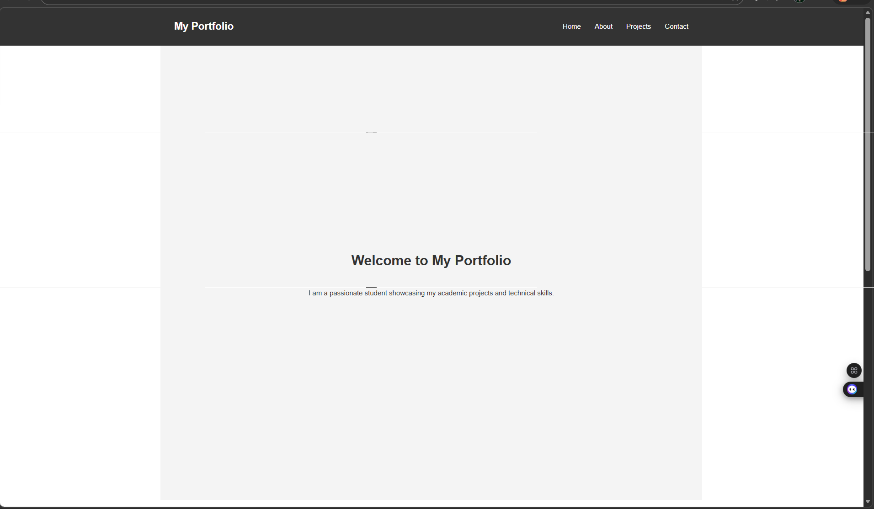

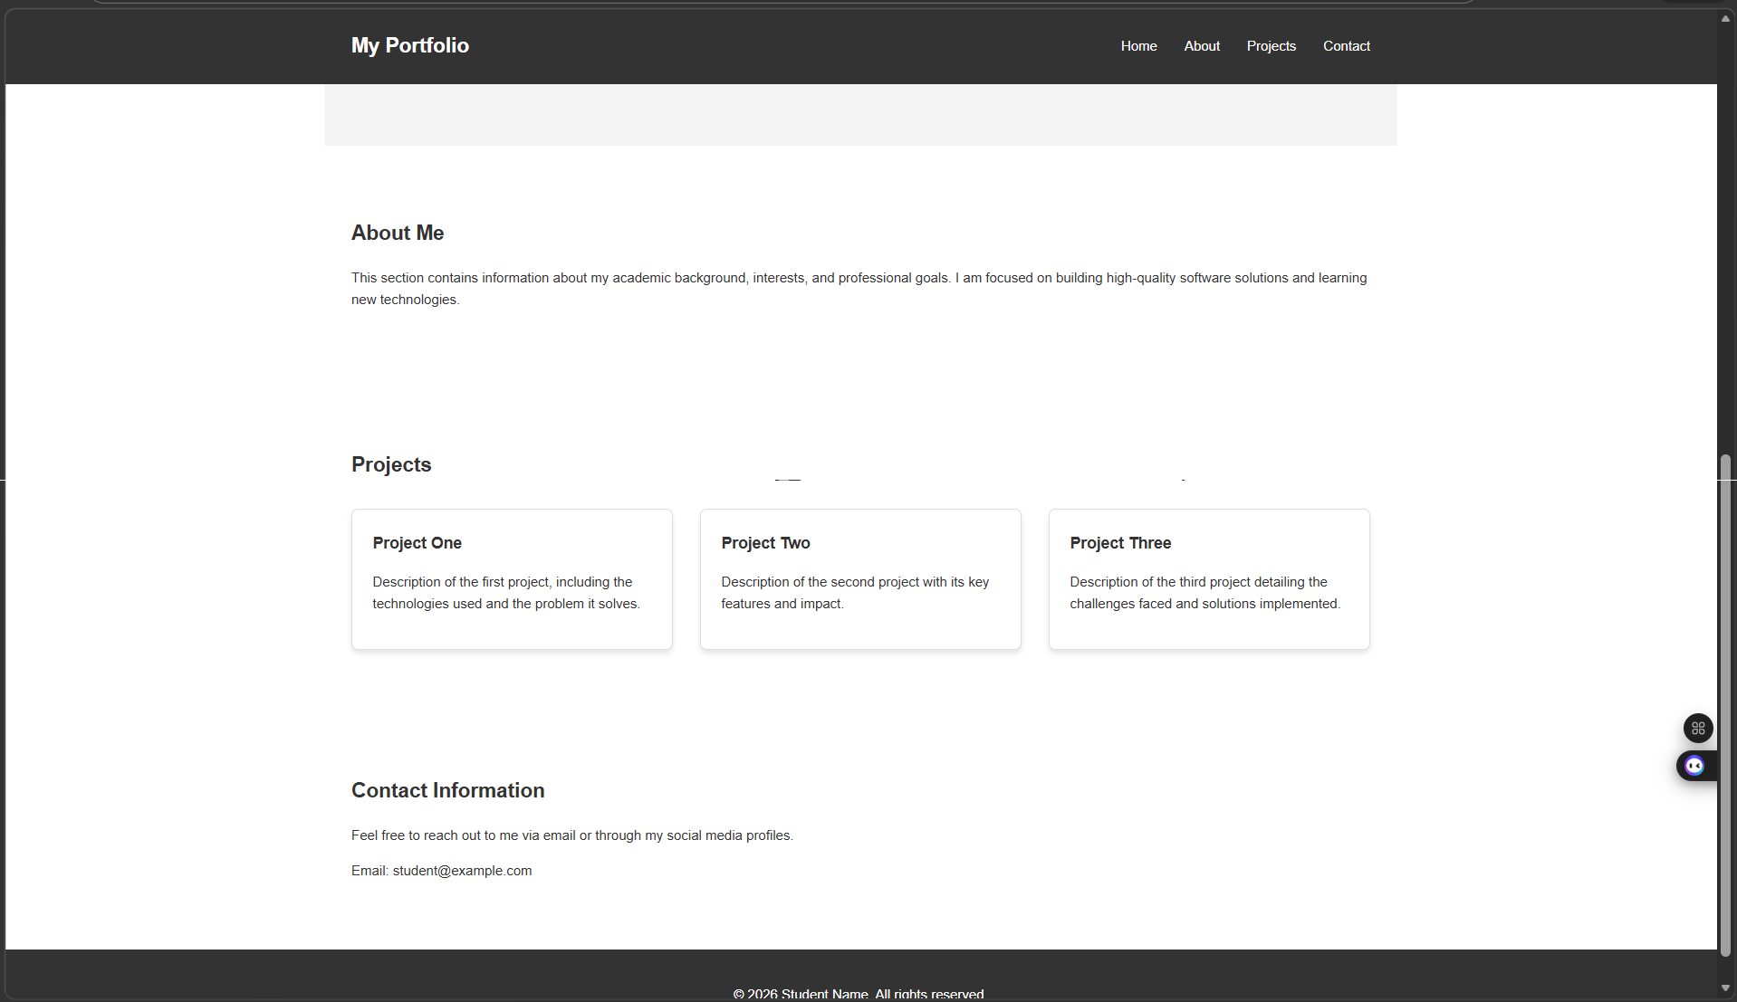

IP address - Personal Portfolio Website

Task-2:
HTML:
<!DOCTYPE html>
<html lang="en">
<head>
<meta charset="UTF-8">
<meta name="viewport" content="width=device-width, initial-scale=1.0">
<title>Gourmet Paradise | Restaurant Landing Page</title>
<link rel="stylesheet" href="https://cdnjs.cloudflare.com/ajax/libs/font-awesome/6.0.0/css/all.min.css">
<link href="https://fonts.googleapis.com/css2?family=Playfair+Display:wght@700&family=Poppins:wght@300;400;600&display=swap" rel="stylesheet">
<style>
:root {
--primary-color: #e67e22;
--secondary-color: #2c3e50;
--white: #ffffff;
--light-bg: #f9f9f9;
--transition: all 0.3s ease;
}

* {
margin: 0;
padding: 0;
box-sizing: border-box;
}
body {
font-family: 'Poppins', sans-serif;
line-height: 1.6;
color: var(--secondary-color);
background-color: var(--light-bg);
scroll-behavior: smooth;
}
/* Navigation Bar */
nav {
background-color: var(--white);
display: flex;
justify-content: space-between;
align-items: center;
padding: 1.5rem 5%;
position: fixed;
top: 0;
width: 100%;
z-index: 1000;
box-shadow: 0 2px 10px rgba(0,0,0,0.1);
}
.logo {
font-family: 'Playfair Display', serif;
font-size: 1.8rem;
color: var(--primary-color);
font-weight: 700;
}
.nav-links {
display: flex;
list-style: none;
}
.nav-links li {
margin-left: 2rem;
}
.nav-links a {
text-decoration: none;
color: var(--secondary-color);
font-weight: 600;
transition: var(--transition);
}
.nav-links a:hover {
color: var(--primary-color);
}
/* Hero Section */
#home {
height: 100vh;
background: linear-gradient(rgba(0,0,0,0.6), rgba(0,0,0,0.6)), url('https://images.unsplash.com/photo-1514362545857-3bc16c4c7d1b?auto=format&fit=crop&w=1350&q=80');
background-size: cover;
background-position: center;
display: flex;
flex-direction: column;
justify-content: center;
align-items: center;
text-align: center;
color: var(--white);
padding: 0 1rem;
}
#home h1 {
font-family: 'Playfair Display', serif;
font-size: 4rem;
margin-bottom: 1rem;
animation: fadeInUp 1s ease;
}
#home p {
font-size: 1.2rem;
margin-bottom: 2rem;
max-width: 600px;
animation: fadeInUp 1.2s ease;
}
.btn {
padding: 0.8rem 2.5rem;
background-color: var(--primary-color);
color: var(--white);
text-decoration: none;
border-radius: 5px;
font-weight: 600;
transition: var(--transition);
animation: fadeInUp 1.4s ease;
}
.btn:hover {
background-color: #d35400;
transform: translateY(-3px);
}
@keyframes fadeInUp {
from {
opacity: 0;
transform: translateY(30px);
}
to {
opacity: 1;
transform: translateY(0);
}
}
section {
padding: 5rem 10%;
}
.section-header {
text-align: center;
margin-bottom: 4rem;
}
.section-header h2 {
font-family: 'Playfair Display', serif;
font-size: 2.5rem;
color: var(--secondary-color);
}
.section-header .underline {
width: 80px;
height: 3px;
background-color: var(--primary-color);
margin: 0.5rem auto;
}
@media (max-width: 768px) {
.nav-links {
display: none; /* Mobile toggle can be added later */
}
#home h1 {
font-size: 2.5rem;
}
}
</style>
</head>
<body>
<nav>
<div class="logo">Gourmet Paradise</div>
<ul class="nav-links">
<li><a href="#home">Home</a></li>
<li><a href="#menu">Menu</a></li>
<li><a href="#gallery">Gallery</a></li>
<li><a href="#contact">Contact</a></li>
</ul>
</nav>
<section id="home">
<h1>Experience Fine Dining</h1>
<p>A culinary journey that delights the senses and warms the soul. Join us for an unforgettable experience.</p>
<a href="#menu" class="btn">Explore Menu</a>
</section>
<!-- Content for other sections will be added in next steps -->
</body>
</html>

CSS:
:root {
--primary-color: #e67e22;
--secondary-color: #2c3e50;
--white: #ffffff;
--light-bg: #f9f9f9;
--transition: all 0.3s ease;
}

* {
margin: 0;
padding: 0;
box-sizing: border-box;
}
body {
font-family: 'Poppins', sans-serif;
line-height: 1.6;
color: var(--secondary-color);
background-color: var(--light-bg);
scroll-behavior: smooth;
}
/* Navigation Bar */
nav {
background-color: var(--white);
display: flex;
justify-content: space-between;
align-items: center;
padding: 1.5rem 5%;
position: fixed;
top: 0;
width: 100%;
z-index: 1000;
box-shadow: 0 2px 10px rgba(0,0,0,0.1);
}
.logo {
font-family: 'Playfair Display', serif;
font-size: 1.8rem;
color: var(--primary-color);
font-weight: 700;
}
.nav-links {
display: flex;
list-style: none;
}
.nav-links li {
margin-left: 2rem;
}
.nav-links a {
text-decoration: none;
color: var(--secondary-color);
font-weight: 600;
transition: var(--transition);
}
.nav-links a:hover {
color: var(--primary-color);
}
/* Hero Section */
#home {
height: 100vh;
background: linear-gradient(rgba(0,0,0,0.6), rgba(0,0,0,0.6)), url('https://images.unsplash.com/photo-1514362545857-3bc16c4c7d1b?auto=format&fit=crop&w=1350&q=80');
background-size: cover;
background-position: center;
display: flex;
flex-direction: column;
justify-content: center;
align-items: center;
text-align: center;
color: var(--white);
padding: 0 1rem;
}
#home h1 {
font-family: 'Playfair Display', serif;
font-size: 4rem;
margin-bottom: 1rem;
animation: fadeInUp 1s ease;
}
#home p {
font-size: 1.2rem;
margin-bottom: 2rem;
max-width: 600px;
animation: fadeInUp 1.2s ease;
}
.btn {
padding: 0.8rem 2.5rem;
background-color: var(--primary-color);
color: var(--white);
text-decoration: none;
border-radius: 5px;
font-weight: 600;
transition: var(--transition);
animation: fadeInUp 1.4s ease;
}
.btn:hover {
background-color: #d35400;
transform: translateY(-3px);
}
@keyframes fadeInUp {
from {
opacity: 0;
transform: translateY(30px);
}
to {
opacity: 1;
transform: translateY(0);
}
}
section {
padding: 5rem 10%;
}
.section-header {
text-align: center;
margin-bottom: 4rem;
}
.section-header h2 {
font-family: 'Playfair Display', serif;
font-size: 2.5rem;
color: var(--secondary-color);
}
.section-header .underline {
width: 80px;
height: 3px;
background-color: var(--primary-color);
margin: 0.5rem auto;
}
@media (max-width: 768px) {
.nav-links {
display: none; /* Mobile toggle can be added later */
}
#home h1 {
font-size: 2.5rem;
}
}

Output:
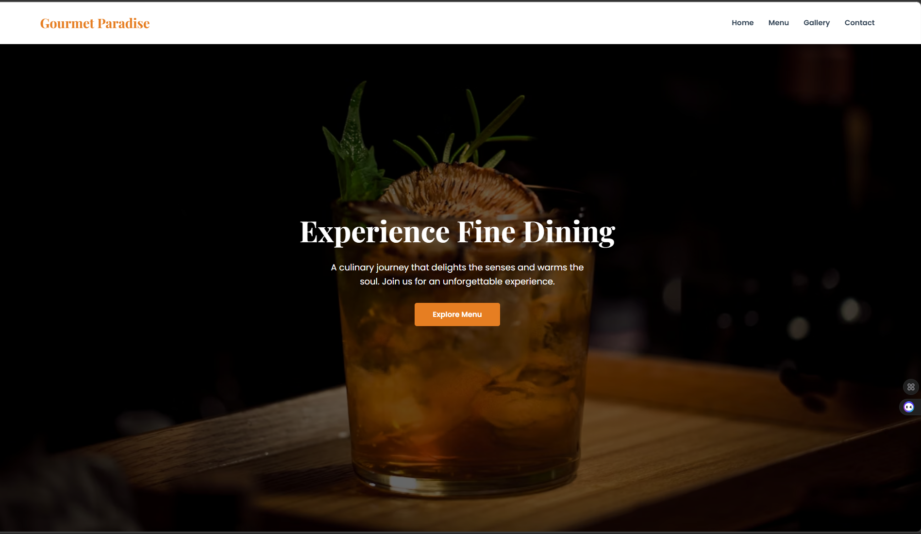

IP address: Gourmet Paradise | Restaurant Landing Page

Task-3:
HTML:
<!DOCTYPE html>
<html lang="en">
<head>
<meta charset="UTF-8">
<meta name="viewport" content="width=device-width, initial-scale=1.0">
<title>Event Registration Form</title>
<link rel="stylesheet" href="https://cdnjs.cloudflare.com/ajax/libs/font-awesome/6.0.0/css/all.min.css">
<link href="https://fonts.googleapis.com/css2?family=Poppins:wght@300;400;600&display=swap" rel="stylesheet">
<style>
body {
font-family: 'Poppins', sans-serif;
background-color: #f9f9f9;
color: #333;
display: flex;
justify-content: center;
align-items: center;
height: 100vh;
margin: 0;
}

.form-container {
background: #fff;
padding: 2rem;
border-radius: 8px;
box-shadow: 0 2px 10px rgba(0, 0, 0, 0.1);
width: 400px;
}
h2 {
text-align: center;
margin-bottom: 1.5rem;
color: #e67e22;
}
.form-group {
margin-bottom: 1.5rem;
}
label {
display: block;
margin-bottom: 0.5rem;
}
input, select {
width: 100%;
padding: 0.8rem;
border: 1px solid #ccc;
border-radius: 4px;
transition: border-color 0.3s;
}
input:focus {
border-color: #e67e22;
}
.error {
color: red;
font-size: 0.9rem;
margin-top: 0.5rem;
}
.btn {
width: 100%;
padding: 0.8rem;
background-color: #e67e22;
color: #fff;
border: none;
border-radius: 4px;
font-size: 1rem;
cursor: pointer;
transition: background-color 0.3s;
}
.btn:hover {
background-color: #d35400;
}
</style>
</head>
<body>
<div class="form-container">
<h2>Event Registration</h2>
<form id="registrationForm">
<div class="form-group">
<label for="name">Name</label>
<input type="text" id="name" name="name" required>
<div class="error" id="nameError"></div>
</div>
<div class="form-group">
<label for="email">Email</label>
<input type="email" id="email" name="email" required>
<div class="error" id="emailError"></div>
</div>
<div class="form-group">
<label for="phone">Phone Number</label>
<input type="text" id="phone" name="phone" required>
<div class="error" id="phoneError"></div>
</div>
<div class="form-group">
<label for="department">Department</label>
<select id="department" name="department" required>
<option value="">Select your department</option>
<option value="CSE">Computer Science</option>
<option value="ECE">Electronics</option>
<option value="ME">Mechanical</option>
<option value="CE">Civil</option>
</select>
<div class="error" id="departmentError"></div>
</div>
<div class="form-group">
<label for="event">Event Selection</label>
<select id="event" name="event" required>
<option value="">Select an event</option>
<option value="workshop">Workshop</option>
<option value="seminar">Seminar</option>
<option value="hackathon">Hackathon</option>
</select>
<div class="error" id="eventError"></div>
</div>
<button type="submit" class="btn">Register</button>
</form>
</div>
<script>
const form = document.getElementById('registrationForm');
form.addEventListener('submit', function(event) {
event.preventDefault();
let valid = true;
// Clear previous errors
document.querySelectorAll('.error').forEach(error => error.textContent = '');
// Name validation
const name = document.getElementById('name').value;
if (name.trim() === '') {
valid = false;
document.getElementById('nameError').textContent = 'Name is required.';
}
// Email validation
const email = document.getElementById('email').value;
const emailPattern = /^[^\s@]+@[^\s@]+\.[^\s@]+$/;
if (!emailPattern.test(email)) {
valid = false;
document.getElementById('emailError').textContent = 'Invalid email format.';
}
// Phone number validation
const phone = document.getElementById('phone').value;
if (phone.length !== 10 || isNaN(phone)) {
valid = false;
document.getElementById('phoneError').textContent = 'Phone number must be 10 digits.';
}
// Department validation
const department = document.getElementById('department').value;
if (department === '') {
valid = false;
document.getElementById('departmentError').textContent = 'Please select a department.';
}
// Event validation
const eventSelection = document.getElementById('event').value;
if (eventSelection === '') {
valid = false;
document.getElementById('eventError').textContent = 'Please select an event.';
}
// If valid, submit the form
if (valid) {
alert('Registration successful!');
form.reset();
}
});
</script>
</body>
</html>

CSS:
body {
font-family: 'Poppins', sans-serif;
background-color: #f9f9f9;
color: #333;
display: flex;
justify-content: center;
align-items: center;
height: 100vh;
margin: 0;
}

.form-container {
background: #fff;
padding: 2rem;
border-radius: 8px;
box-shadow: 0 2px 10px rgba(0, 0, 0, 0.1);
width: 400px;
}
h2 {
text-align: center;
margin-bottom: 1.5rem;
color: #e67e22;
}
.form-group {
margin-bottom: 1.5rem;
}
label {
display: block;
margin-bottom: 0.5rem;
}
input, select {
width: 100%;
padding: 0.8rem;
border: 1px solid #ccc;
border-radius: 4px;
transition: border-color 0.3s;
}
input:focus {
border-color: #e67e22;
}
.error {
color: red;
font-size: 0.9rem;
margin-top: 0.5rem;
}
.btn {
width: 100%;
padding: 0.8rem;
background-color: #e67e22;
color: #fff;
border: none;
border-radius: 4px;
font-size: 1rem;
cursor: pointer;
transition: background-color 0.3s;
}
.btn:hover {
background-color: #d35400;
}

Output:
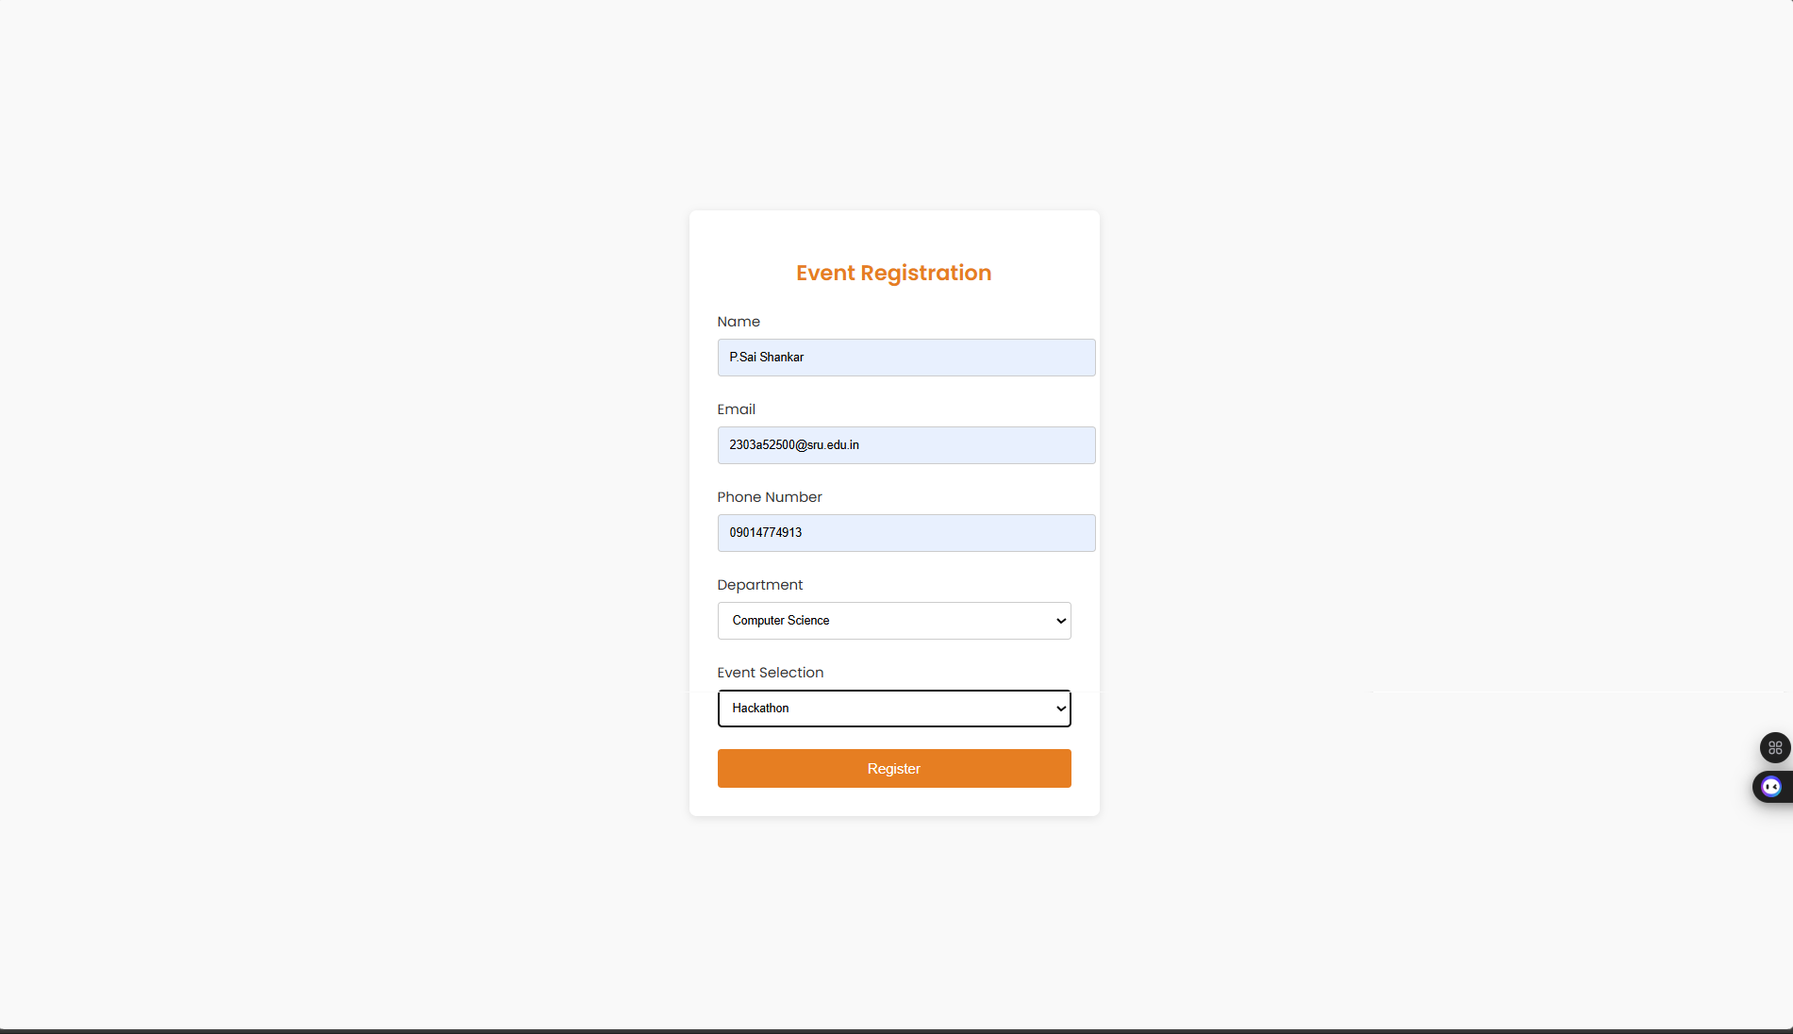

IP address: Event Registration Form

Task-4:
HTML:
<!DOCTYPE html>
<html lang="en">
<head>
<meta charset="UTF-8">
<meta name="viewport" content="width=device-width, initial-scale=1.0">
<title>E-Commerce Product Page</title>
<link href="https://fonts.googleapis.com/css2?family=Poppins:wght@300;400;600&display=swap" rel="stylesheet">
<style>
body {
font-family: 'Poppins', sans-serif;
margin: 0;
padding: 0;
background-color: #f9f9f9;
}

header {
background-color: #333;
color: #fff;
padding: 1rem;
display: flex;
justify-content: space-between;
align-items: center;
}
.cart-counter {
position: relative;
font-size: 1.2rem;
}
.cart-counter span {
background: #e67e22;
border-radius: 50%;
padding: 0.2rem 0.5rem;
position: absolute;
top: -5px;
right: -10px;
color: white;
font-size: 0.8rem;
}
.product-grid {
display: grid;
grid-template-columns: repeat(auto-fill, minmax(250px, 1fr));
gap: 1.5rem;
padding: 2rem;
}
.product-card {
background: white;
border-radius: 8px;
box-shadow: 0 2px 10px rgba(0, 0, 0, 0.1);
padding: 1rem;
text-align: center;
transition: transform 0.2s;
}
.product-card:hover {
transform: translateY(-5px);
}
.product-image {
width: 100%;
height: 150px;
object-fit: cover;
border-radius: 8px;
}
.product-title {
font-size: 1.2rem;
margin: 0.5rem 0;
}
.product-price {
color: #e67e22;
font-size: 1.1rem;
}
.add-to-cart {
background-color: #e67e22;
color: white;
border: none;
padding: 0.5rem 1rem;
border-radius: 4px;
cursor: pointer;
transition: background-color 0.3s;
margin-top: 0.5rem;
}
.add-to-cart:hover {
background-color: #d35400;
}
.added-feedback {
display: none;
color: green;
margin-top: 0.5rem;
}
</style>
</head>
<body>
<header>
<h1>E-Commerce Store</h1>
<div class="cart-counter">
Cart <span id="cartCount">0</span>
</div>
</header>
<div class="product-grid" id="productGrid">
<!-- Product cards will be generated here -->
</div>
<script>
const products = [
{ id: 1, title: 'Product 1', price: 29.99, image: 'https://via.placeholder.com/250' },
{ id: 2, title: 'Product 2', price: 39.99, image: 'https://via.placeholder.com/250' },
{ id: 3, title: 'Product 3', price: 19.99, image: 'https://via.placeholder.com/250' },
{ id: 4, title: 'Product 4', price: 49.99, image: 'https://via.placeholder.com/250' }
];
let cartCount = 0;
function addToCart() {
cartCount++;
document.getElementById('cartCount').textContent = cartCount;
const feedback = this.nextElementSibling;
feedback.style.display = 'block';
setTimeout(() => {
feedback.style.display = 'none';
}, 2000);
}
function renderProducts() {
const productGrid = document.getElementById('productGrid');
products.forEach(product => {
const card = document.createElement('div');
card.className = 'product-card';
card.innerHTML = `
<img src="${product.image}" alt="${product.title}" class="product-image">
<h2 class="product-title">${product.title}</h2>
<p class="product-price">$${product.price.toFixed(2)}</p>
<button class="add-to-cart">Add to Cart</button>
<div class="added-feedback">Added to cart!</div>
`;
const addToCartButton = card.querySelector('.add-to-cart');
addToCartButton.addEventListener('click', addToCart);
productGrid.appendChild(card);
});
}
renderProducts();
</script>
</body>
</html>

CSS:
body {
font-family: 'Poppins', sans-serif;
margin: 0;
padding: 0;
background-color: #f9f9f9;
}

header {
background-color: #333;
color: #fff;
padding: 1rem;
display: flex;
justify-content: space-between;
align-items: center;
}
.cart-counter {
position: relative;
font-size: 1.2rem;
}
.cart-counter span {
background: #e67e22;
border-radius: 50%;
padding: 0.2rem 0.5rem;
position: absolute;
top: -5px;
right: -10px;
color: white;
font-size: 0.8rem;
}
.product-grid {
display: grid;
grid-template-columns: repeat(auto-fill, minmax(250px, 1fr));
gap: 1.5rem;
padding: 2rem;
}
.product-card {
background: white;
border-radius: 8px;
box-shadow: 0 2px 10px rgba(0, 0, 0, 0.1);
padding: 1rem;
text-align: center;
transition: transform 0.2s;
}
.product-card:hover {
transform: translateY(-5px);
}
.product-image {
width: 100%;
height: 150px;
object-fit: cover;
border-radius: 8px;
}
.product-title {
font-size: 1.2rem;
margin: 0.5rem 0;
}
.product-price {
color: #e67e22;
font-size: 1.1rem;
}
.add-to-cart {
background-color: #e67e22;
color: white;
border: none;
padding: 0.5rem 1rem;
border-radius: 4px;
cursor: pointer;
transition: background-color 0.3s;
margin-top: 0.5rem;
}
.add-to-cart:hover {
background-color: #d35400;
}
.added-feedback {
display: none;
color: green;
margin-top: 0.5rem;
}

Output:
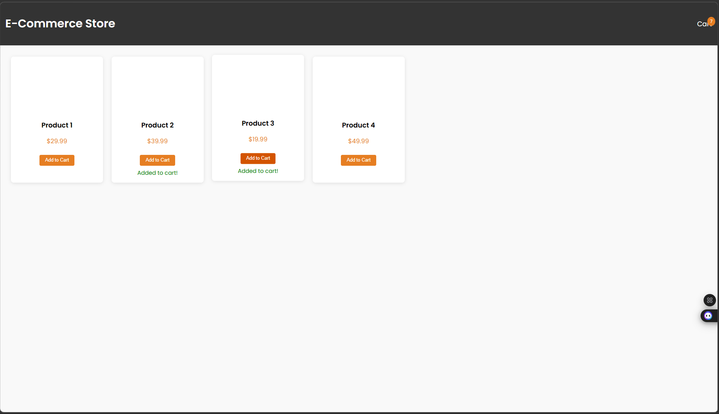

IP address: E-Commerce Product Page

Task-5:
HTML:
<!DOCTYPE html>
<html lang="en">
<head>
<meta charset="UTF-8">
<meta name="viewport" content="width=device-width, initial-scale=1.0">
<title>Responsive Web Page Layout</title>
<link href="https://fonts.googleapis.com/css2?family=Poppins:wght@300;400;600&display=swap" rel="stylesheet">
<style>
body {
font-family: 'Poppins', sans-serif;
margin: 0;
padding: 0;
display: flex;
flex-direction: column;
min-height: 100vh;
}

header {
background-color: #333;
color: white;
padding: 1rem 2rem;
display: flex;
justify-content: space-between;
align-items: center;
}
nav ul {
list-style: none;
display: flex;
gap: 1.5rem;
}
nav a {
color: white;
text-decoration: none;
transition: color 0.3s;
}
nav a:hover {
color: #e67e22;
}
main {
flex: 1;
padding: 2rem;
display: flex;
flex-direction: column;
align-items: center;
justify-content: center;
}
.placeholder {
width: 100%;
max-width: 800px;
height: 300px;
background-color: #e0e0e0;
border-radius: 8px;
margin-bottom: 1.5rem;
display: flex;
align-items: center;
justify-content: center;
color: #666;
}
footer {
background-color: #333;
color: white;
text-align: center;
padding: 1rem 0;
}
@media (max-width: 768px) {
nav ul {
flex-direction: column;
gap: 1rem;
}
}
@media (max-width: 480px) {
header {
flex-direction: column;
align-items: flex-start;
}
nav ul {
align-items: flex-start;
}
}
</style>
</head>
<body>
<header>
<h1>My Website</h1>
<nav>
<ul>
<li><a href="#home">Home</a></li>
<li><a href="#about">About</a></li>
<li><a href="#services">Services</a></li>
<li><a href="#contact">Contact</a></li>
</ul>
</nav>
</header>
<main>
<div class="placeholder">Main Content Area</div>
<div class="placeholder">Additional Content Area</div>
</main>
<footer>
<p>&copy; 2026 My Website. All rights reserved.</p>
</footer>
</body>
</html>

CSS:
body {
font-family: 'Poppins', sans-serif;
margin: 0;
padding: 0;
display: flex;
flex-direction: column;
min-height: 100vh;
}

header {
background-color: #333;
color: white;
padding: 1rem 2rem;
display: flex;
justify-content: space-between;
align-items: center;
}
nav ul {
list-style: none;
display: flex;
gap: 1.5rem;
}
nav a {
color: white;
text-decoration: none;
transition: color 0.3s;
}
nav a:hover {
color: #e67e22;
}
main {
flex: 1;
padding: 2rem;
display: flex;
flex-direction: column;
align-items: center;
justify-content: center;
}
.placeholder {
width: 100%;
max-width: 800px;
height: 300px;
background-color: #e0e0e0;
border-radius: 8px;
margin-bottom: 1.5rem;
display: flex;
align-items: center;
justify-content: center;
color: #666;
}
footer {
background-color: #333;
color: white;
text-align: center;
padding: 1rem 0;
}
@media (max-width: 768px) {
nav ul {
flex-direction: column;
gap: 1rem;
}
}
@media (max-width: 480px) {
header {
flex-direction: column;
align-items: flex-start;
}
nav ul {
align-items: flex-start;
}
}

Output:
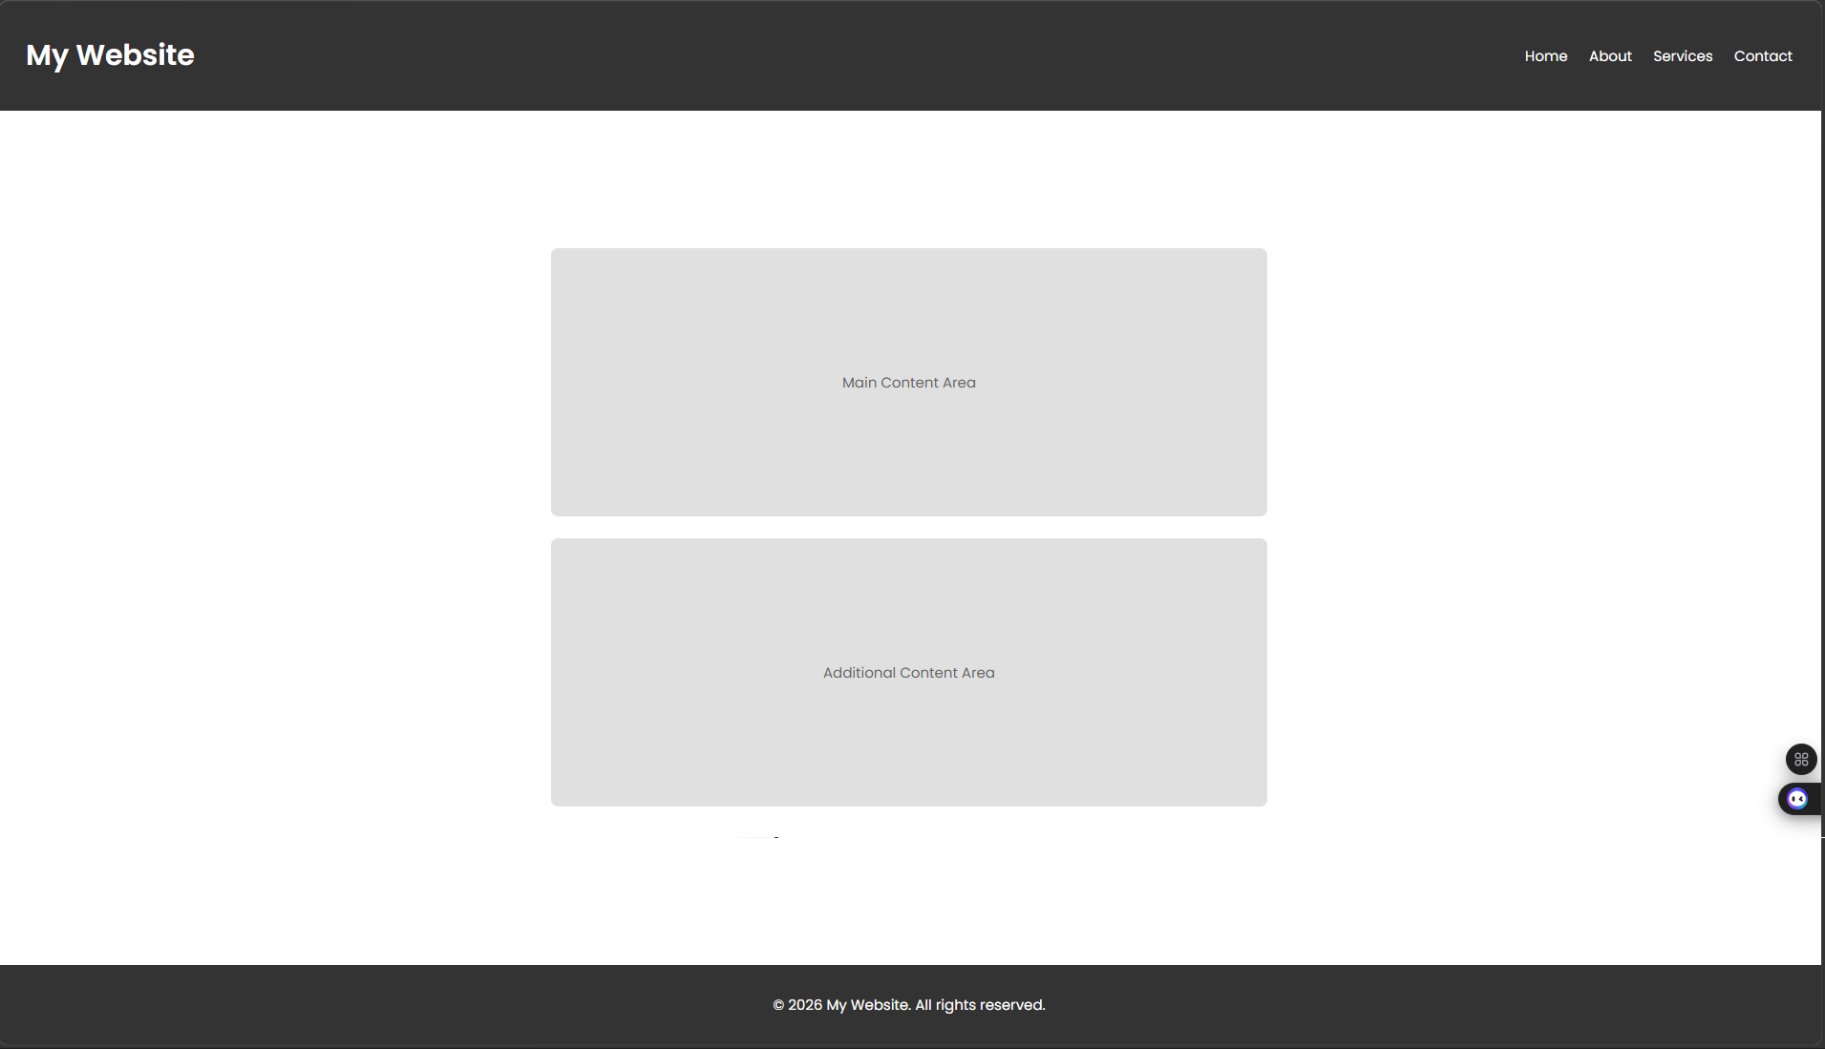

IP address: Responsive Web Page Layout

